Upward Performance Women’s Adjustable Cap
$25.00

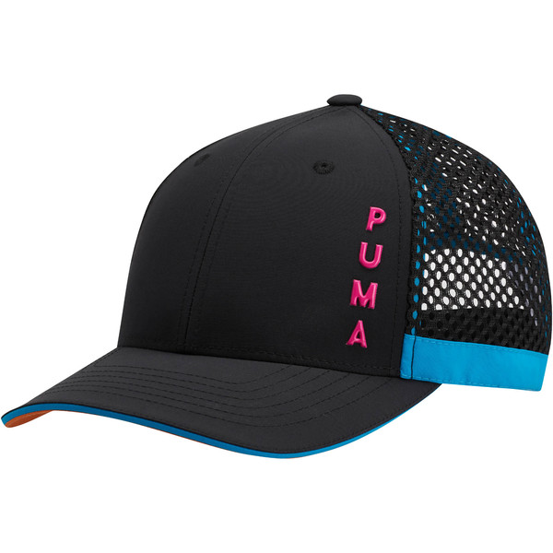

DETAILS
- Adjustable stretch fit
- Dual material crown with mesh back
- Contrast color rimmed brim
- Nylon webbed strap closure with PUMA branded adjuster
- Curved brim
- Embroidered eyelets
- Rubber print vertical PUMA branding down left crown
- One size fits all
- Material: 50% Polyester 50% Nylon

